Project Overview
Project: Interactive Calculator
Internship domain: Front-End Development
Core technologies: HTML5, CSS3, and JavaScript
This report documents the project completed for the corresponding CodeAlpha Front-End Development task. Descriptions of optional or implementation-dependent features should be checked against the final source code before submission.
1. Introduction
The Calculator was completed as part of my CodeAlpha Front-End Development Internship. The project is a browser-based calculator designed to accept user input and perform basic arithmetic operations through a simple interface.
2. Project Objectives
- Build a basic calculator using HTML, CSS, and JavaScript.
- Create a user interface with buttons and a display screen.
- Support addition, subtraction, multiplication, and division.
- Handle user input and provide a clear/reset function.
- Display calculation results as part of the interaction.
3. Technologies Used
- HTML5 — creates the calculator structure, display area, and buttons.
- CSS3 — styles the calculator, display, button arrangement, and visual states.
- JavaScript — processes input, performs arithmetic operations, and updates the display.
4. Project Design and Structure
The interface is organized into a calculator container, a display screen, numeric buttons, arithmetic operator buttons, and control buttons. The layout is intended to make the available operations easy to identify and use.
5. Implementation
- HTML structure: create the calculator container, display screen, number buttons, operator buttons, clear control, and equals control.
- CSS styling: arrange the buttons in a clear layout and apply consistent sizing, spacing, colors, and other visual styling.
- JavaScript behavior: capture button input, manage the calculation state, perform arithmetic operations, and show the result on the display.
6. Main Features
- Numeric input through calculator buttons.
- Addition (+), subtraction (−), multiplication (×), and division (÷).
- Display screen for entered values and results.
- Clear/reset control.
- Interactive button behavior.
- Optional bonus: keyboard input and additional styling, if included in the submitted implementation.
7. Conclusion
The Calculator task helped me combine HTML, CSS, and JavaScript to build a functional interactive application. It improved my understanding of JavaScript logic and front-end user interaction.
8. Project Screenshots
Insert screenshots from your own completed project in the spaces below. Use genuine screenshots of the submitted application; do not leave the placeholders in the final submission.
Figure 1. Calculator interface showing the display and buttons

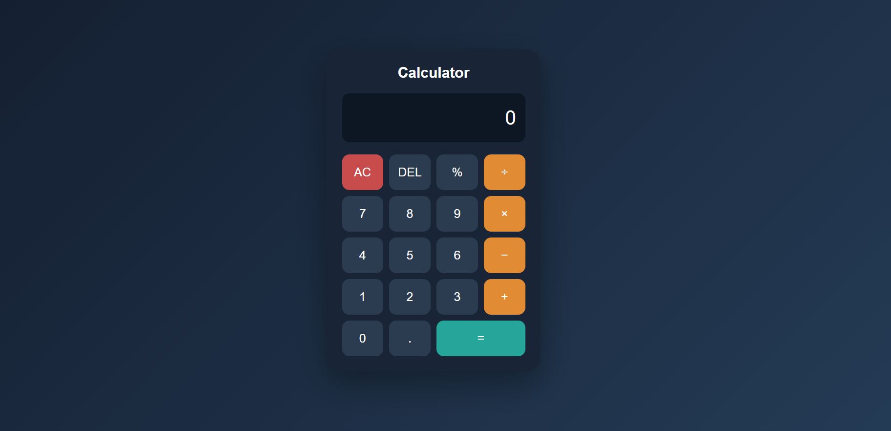
Figure 2. Example arithmetic operation and result
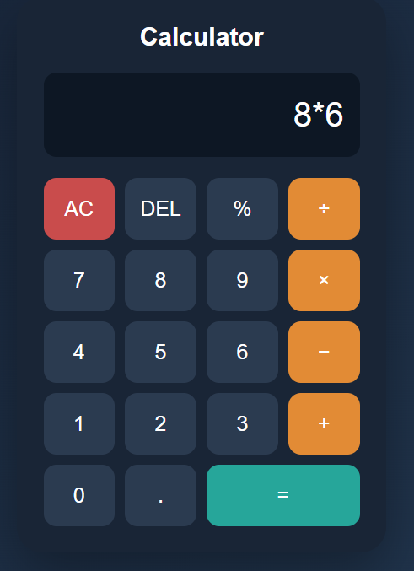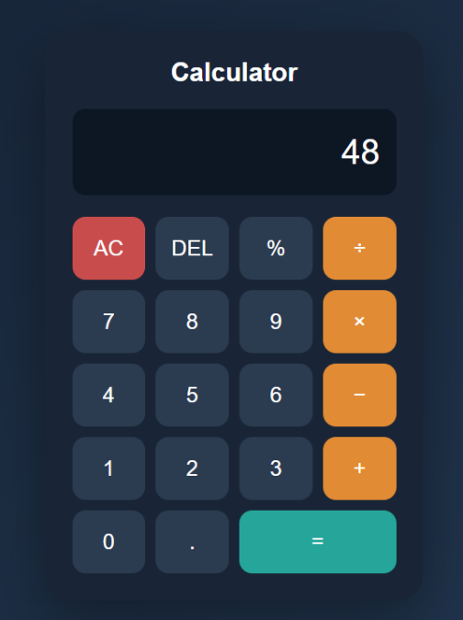

Figure 3. Clear/reset behavior


